SpeedZone Fundraising Event For
Nogales High School Band May 3 & 4!
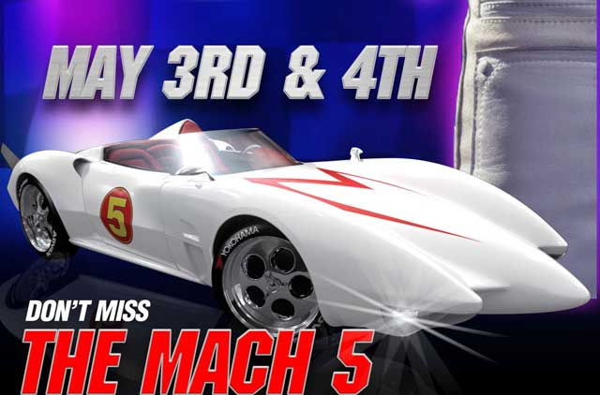



SpeedZone is Hosting a Fundraiser for the Nogales High School Band This Weekend
May 3rd & 4th from 11am - 4pm

Purchase a special fundraising ticket for $20 with a portion of proceeds going back to the band! During these days you can check out the Mach 5 car from the Warner Bros. movie Speed Racer. There will be booth displays, entertainment, music and more. KIIS FM will be out on Sunday May 4th. Win cool prizes and more!

The Nogales High School Regiment is proud to be one of only 10 bands across the U.S. invited to perform in the internationally famous, Macy's 2008 Thanksgiving Day Parade in New York City!

www.nogalesnobleregiment.com

BRING THIS FLIER AND PRESENT TO SZ CASHIER TO RECEIVE PROMOTIONS DISCOUNT
www.SpeedZone.com

